Milborne Port Football Club
Founded 1891
President – Stuart Hinks
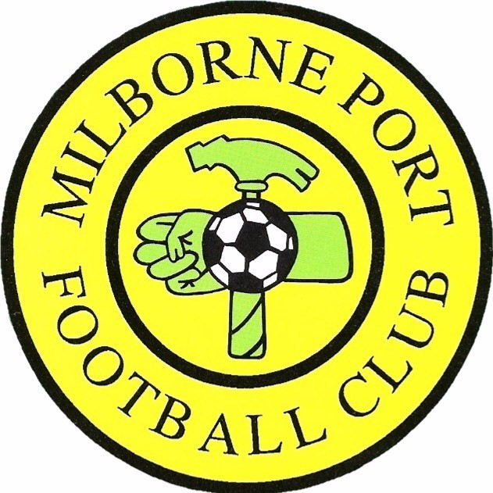

Chairman Vice-Chairman Secretary Treasurer Club Welfare Officer
Steve Davis Matt Lockey Rob Lockey Janet Davis Victoria Rymell

Agenda for the Annual General Meeting
to be held at 7:45pm on Monday 10th May 2023
at Milborne Port Sports & Social Club

- Welcome
- Apologies for Absence
- Minutes of Last Year’s AGM
- Chair’s Report
- Treasurer’s Report
- Secretary’s Report
- Disbanding of Current Committee
- Committee for 2023-24 Season
  - Chairperson
  - Vice Chairman
  - Treasurer
  - Secretary
  - Welfare Officer
  - Groundsman
  - Committee Members (All managers +)
  - Kit Washers
- Plans for Next Season - Teams
  - Under 7s – Ben Southern - YDMSL
  - Under 8s – Marco Ferrari - YDMSL
  - Under 9s – James Quick - YDMSL
  - Under 10s – Lloyd Studley - YDMSL
  - Under 12s – Mark Bareham - YDMSL
  - Under 13s – Steven Hill - YDFL
  - Under 14s – Gavin Furlong – YDFL
  - Under 16s – Dave Colohan – YDFL
  - Under 18s – Jody Baunton – DFL
  - First Team – Mark Bennett – DFL
  - Reserves – Ben Tupman – YDFL
  - A Team – D Colohan - YDFL
      - Any Other Business

