Milborne Port Football Club
Founded 1891
President – Stuart Hinks
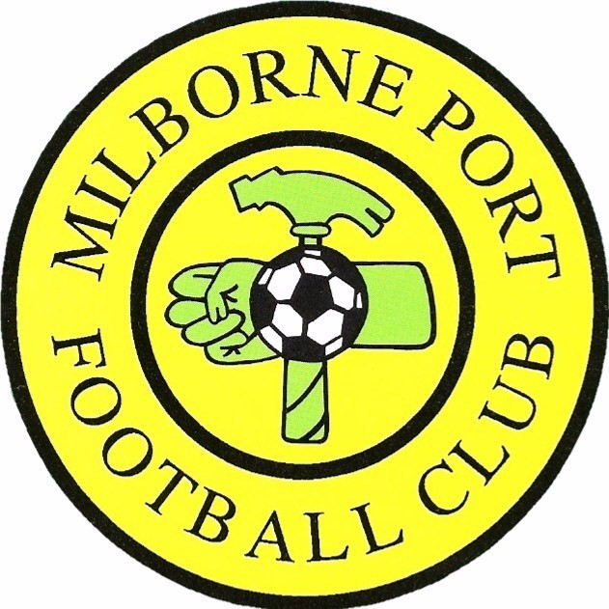

Chairman Vice-Chairman Secretary Treasurer Club Welfare Officer
Rob Lockey Matt Lockey Ally Baker Janet Davis Victoria Rymell

Meeting Agenda – 12th June 2023

- Apologies for absence
- Minutes of the last meeting
- Finance
- End of Season Presentation
- Preparation for next season
- Safeguarding
- Fundraising
- AOB

Next meeting – Monday 3rd July 2023 7.45pm

